# System Diagram of Health Monitoring Device:

Below shows the System flow diagram of the device which includes both software and hardware information flow:

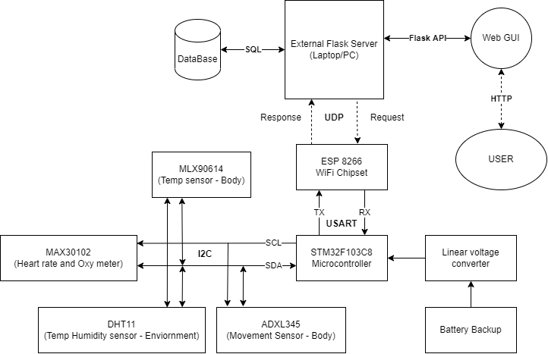

* All the sensors use I2C protocol to communicate with the main microcontroller STM32 and it collects the data and store it in local variables.
* We will be using an external Flask server which will be hosted on a laptop/pc and to connect the microcontroller with the server we will use ESP8266 WiFi Chipset which will be communicating via USART with the main microcontroller.
* The server will set an interval every one second to request the sensor data from microcontroller and after receiving the request the ESP8266 will send the sensor data in JSON format.
* After getting the JSON response by the server, it will convert it to local variables and it will generate a query with SQL to save those data in a database.
* The server then further pushes the data into the Web GUI via Flask APIs and the user connected over the same network can view the GUI via HTTP protocol.

# Approximate Device size:

**STM32** - 23mm x 53mm

**MAX30102** - 14.1mm x 14.1mm

**MLX90614** – 17mm x 12mm

**DHT11** – 12mm x 15.1mm

**ADXL345** – 15.2mm x 20.4mm

**ESP8266** – 16mm x 24mm

**Battery** – 65mm x 20mm

The calculated dimension of the device is - **80 mm x 50 mm x 25 mm**

And the maximum device size can not be more than – **90 m x 60 mm x 35 mm**

# Approximate weight of the Device:

**STM32** – 8g

**MAX30102** – 5g

**MLX90614** – 3g

**DHT11** – 3g

**ADXL345** – 0.5g

**ESP8266** – 1g

**Battery** – 50g

**PCB** – ~30g

**BODY** – ~80g

Total calculated weight of the device **~180 grams**